Updating Robot FIrmware

# **Description**

This tutorial is a guide for updating Vex IQ robot firmware through the Vex OS utility

# **Instructions**

## **Log into Laptops**

1. Take a laptop for your team from the Vex IQ laptop cart
2. Power on and log into the laptop
   1. Login: Student
   2. Password: obfuscate

## **Opening VEX OS**

1. Look on the desktop for the VEXos Utility icon. Double click the “VEXos Utility” icon.  
   1. 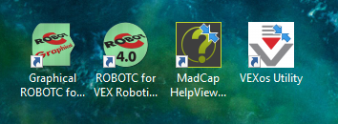
2. The VEXos utility should appear

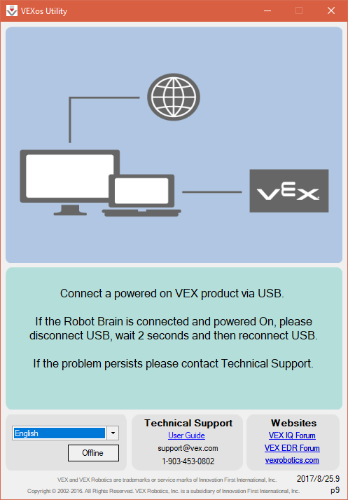

1. If updates are available, select “Download & Install”



1. Insert a charged battery into the Robot Brain
2. Connect the Brain to the computer with the USB cable and to the controller with the Ethernet cable

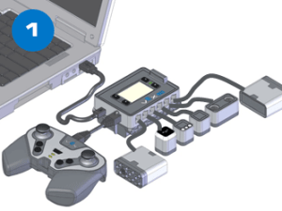

1. Power on the robot brain
2. Select Install to update the Vex IQ brain, controller, motors, sensors, etc. so that all devices have a green boarder. Follow any on-screen instructions.

